Project Design Phase-II
Data Flow Diagram & User Stories

Date | 20 February 2026
Team ID | LTVIP2026TMIDS80887
Project Name | FreelanceFinder: Discovering Opportunities, Unlocking Potential
Maximum Marks | 4 Marks

Data Flow Diagrams:
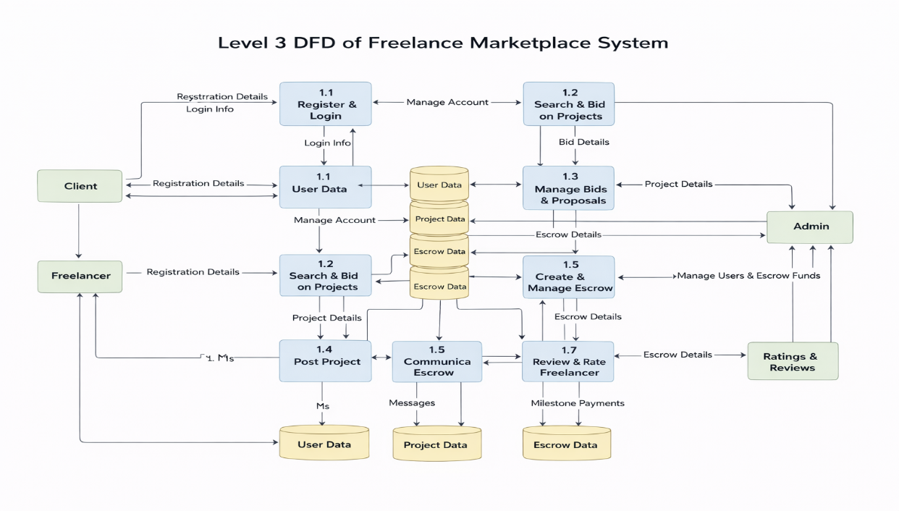
User Stories
User Type | Functional Requirement (Epic) | User Story No | User Story / Task | Acceptance Criteria | Priority | Release
Freelancer (Mobile) | Registration | US-01 | As a freelancer, I can register using email & password | Account is created and redirected to dashboard | High | Sprint-1
Freelancer (Mobile) | Login | US-02 | As a freelancer, I can login using email & password | User authenticated and session created successfully | High | Sprint-1
Freelancer (Mobile) | Profile Management | US-03 | As a freelancer, I can create and update my profile with skills and experience | Profile is saved and visible to clients | High | Sprint-1
Freelancer (Mobile) | Job Search | US-04 | As a freelancer, I can search and filter freelance jobs | Relevant jobs displayed based on filters | High | Sprint-2
Freelancer (Mobile) | Apply for Job | US-05 | As a freelancer, I can apply for jobs with proposals | Application submitted successfully | High | Sprint-2
Freelancer (Mobile) | Proposal Tracking | US-06 | As a freelancer, I can track my submitted proposals | Proposal status is visible (pending/accepted/rejected) | Medium | Sprint-3
Client (Web) | Registration | US-07 | As a client, I can register using email & password | Account created and redirected to dashboard | High | Sprint-1
Client (Web) | Login | US-08 | As a client, I can login securely | User authenticated and session created | High | Sprint-1
Client (Web) | Job Posting | US-09 | As a client, I can post freelance jobs | Job is published and visible to freelancers | High | Sprint-2
Client (Web) | Freelancer Search | US-10 | As a client, I can search freelancers based on skills | Relevant freelancers displayed | High | Sprint-2
Client (Web) | Hire Freelancer | US-11 | As a client, I can hire freelancers for jobs | Freelancer assigned and notified | High | Sprint-3
Client (Web) | Payment Management | US-12 | As a client, I can make payments securely | Payment processed and receipt generated | High | Sprint-3
Admin | User Management | US-13 | As an admin, I can manage users (freelancers & clients) | Users can be added/removed/updated | High | Sprint-1
Admin | Job Monitoring | US-14 | As an admin, I can monitor posted jobs | Jobs reviewed and controlled if needed | Medium | Sprint-2
Admin | Dispute Management | US-15 | As an admin, I can handle disputes between users | Issues resolved and status updated | Medium | Sprint-3

